**1Project Deliverable 2 – Documentation and Coding**

**Faculty Name:** Information Technology

**Module Code:** ITECA3-B12

**Module Name:** Web Development and e-Commerce

**Content Writer:** Kariboba Mpwampu

**Copy Editor:** Mr Kyle Keens

**Submission Date:** Block 2 Week 4

|  |  |
| --- | --- |
| **Student Name** | Lucinda Zachos |
| **Student Number** | Y34VR5C17 |
| **Project Title** | Daughters of Artemis E-Commerce Website and Database |
| **Submission Date** | 7 June 2023 |

**Table of Contents**

2.1 Introduction 3

2.2 Prototyping 3

2.3 Designing 3

2.4 Coding 3

2.5 Conclusion 4

2.6 Sign-off 4

**Table of Figures**

Figure 1: Daughters of Artemis EERD Diagram, (Mortier, 2023) 6

Figure 2: Daughters of Artemis Context Diagram 7

# Introduction

Provide an introduction in less than 200 words.

# Prototyping

Provide the screen shots of the two responsive prototypes asked in the project specification document. Each prototype must illustrate how all the pages of the website will be displayed on smart phones, tablets, and desktops.

1. **Prototype 1.**
2. **Prototype 2.**

Your client must select the prototype you should use for the website development.

# Security Measures

1. Install SSL
2. Make passwords uncrackable
3. Keep your website up to date
4. Run regular backups
5. Hashing passwords
6. Prepared statements with parameterized queries.

# Designing

1. **Class Responsibility Collaborator (CRC) cards**

|  |  |
| --- | --- |
| Customer | |
| Store customer information  Add products to cart  Add products to Wishlist  Place orders  View payment status | Cart  Wishlist  Order  Payment |

|  |  |
| --- | --- |
| Category | |
| Store category information  Retrieve products by category  Add products to Wishlist  Place orders  View payment status | Product |

|  |  |
| --- | --- |
| Product | |
| Store product information  Retrieve product information  Add products to Wishlist  Place orders  View payment status | Category  Cart  Wishlist  Order  Order Item |

|  |  |
| --- | --- |
| Order | |
| Store order information  Add items to order | Customer  Order Item  Payment  Shipment |

|  |  |
| --- | --- |
| Order Item | |
| Store order item information | Order  Product |

|  |  |
| --- | --- |
| Shipment | |
| Store shipment information | Order |

|  |  |
| --- | --- |
| Cart | |
| Store cart information  Calculate cart total | Customer  Product |

|  |  |
| --- | --- |
| Wishlist | |
| Store Wishlist information | Customer  Product |

|  |  |
| --- | --- |
| Payment | |
| Store payment information | Customer  Order |

|  |  |
| --- | --- |
| Seller | |
| Store seller information |  |

1. **Enhanced Entity Relationship Diagram (EERD)**

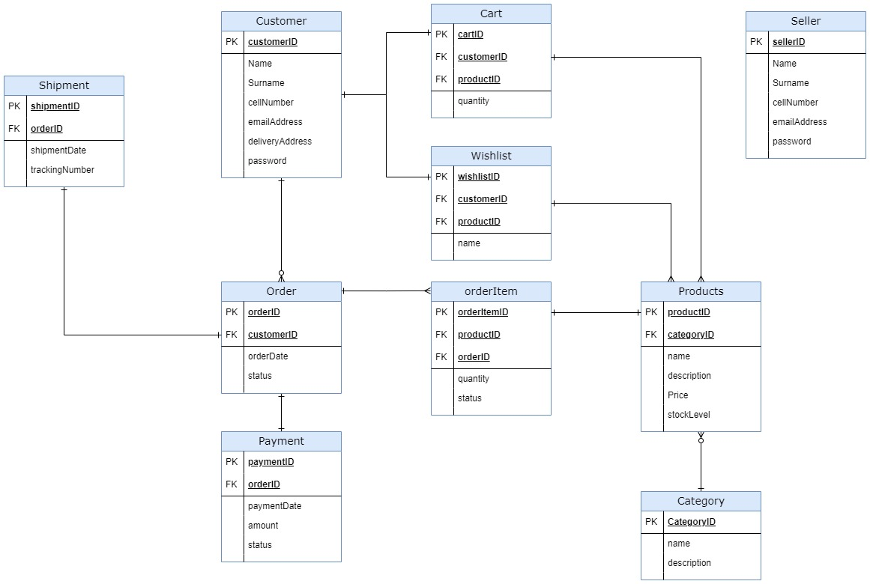

Figure 1: Daughters of Artemis - EERD Diagram, (Mortier, 2023)

1. **Context Diagram**

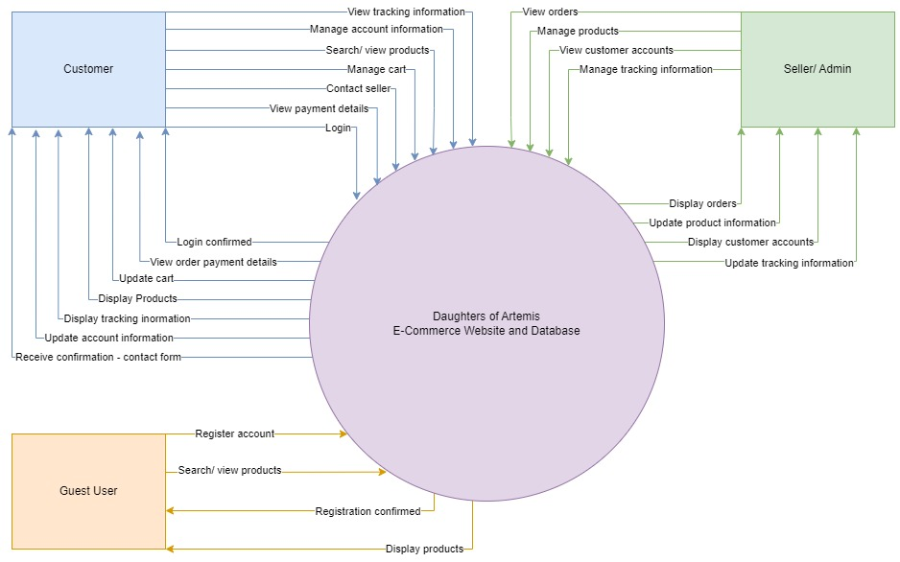

Figure 2: Daughters of Artemis - Context Diagram

1. **Data Flow Diagram (DFD)**
2. **Use Case Diagram**

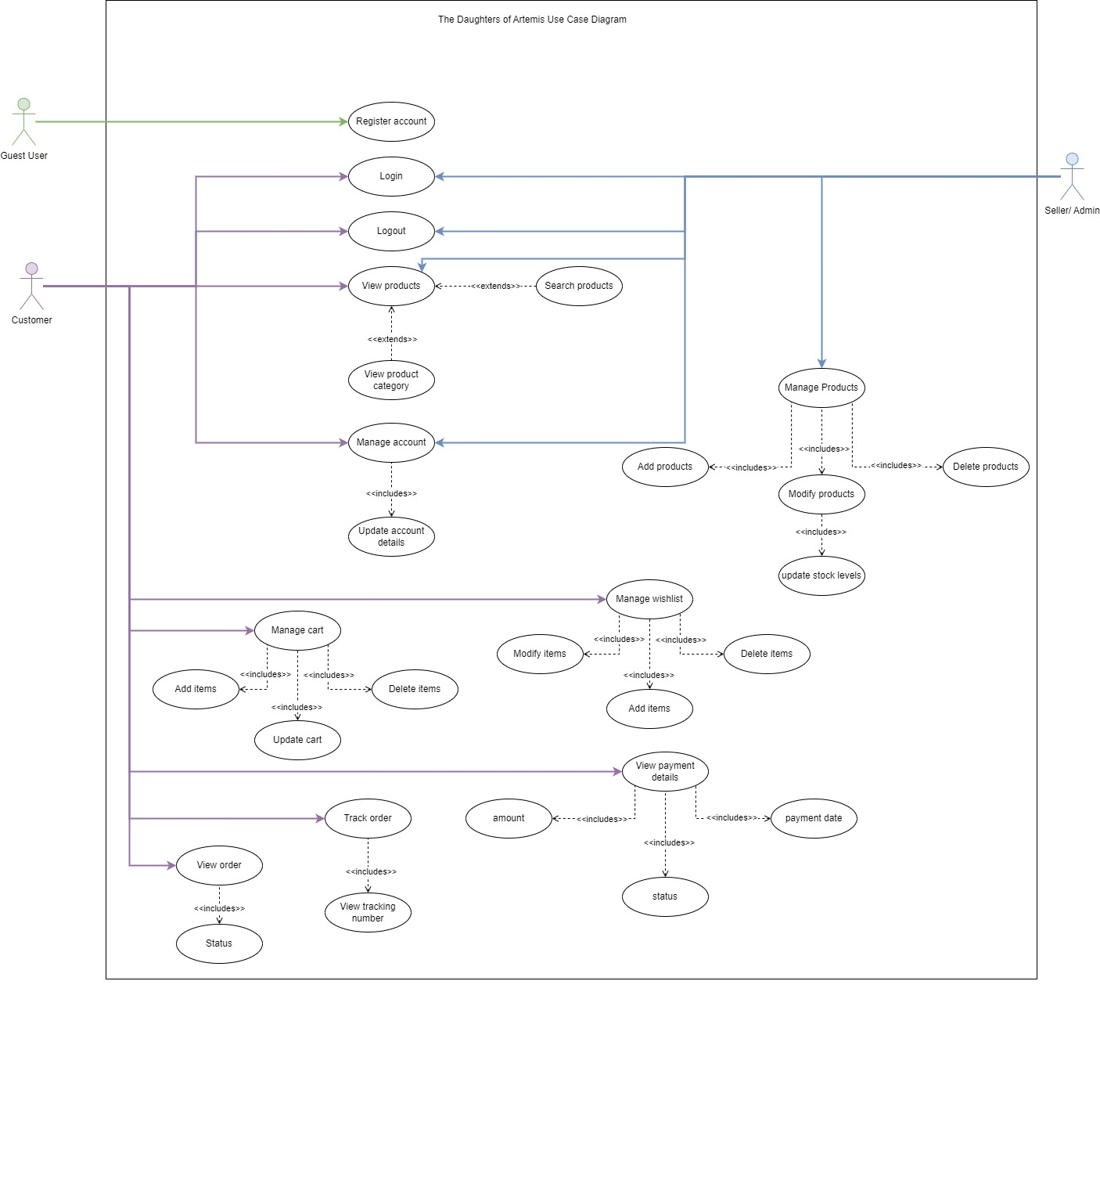

Figure 3: Daughters of Artemis - Use Case Diagram

1. **Database Design**

# Coding

Provide the screenshots and code samples of the final website. You do not have to print every code on your website. Use the following as guideline and explain what each sample code provided is used for on the website:

1. **Screenshots**
2. **Sample PHP Code**
3. **Sample HTML Code**
4. **Sample JavaScript Code**
5. **Sample CSS Code**
6. **Sample MySQL Table Screenshots**

# Conclusion

# Sign-off

|  |  |  |  |
| --- | --- | --- | --- |
|  |  |  |  |
| [Tasmin Mackillican], Project Client  Date: _____________________ |  |  | [Lucinda Zachos], Project Manager and Developer  Date: _____________________ |

# References

Clifford Stein , Robert Drysdale, Kenneth Bogart, 2011. *Discrete Mathematics for computer scientists.* United states of America: Pearson Education.

Gaddis, T., 2013. *Starting out with Programming Logic & Design.* United states: Pearson Education.

Hagarty, R., 2002. *Discrete Mathematics for computing.* Malaysia: Pearson Education limited.

Kolman, B., 1997. *Introductou Linear Algebra with applications.* New Yersey: Prentice -Hall, Inc.

Mortier, G. d., 2023. *Vertabelo.* [Online]   
Available at: https://vertabelo.com/blog/er-diagram-for-online-shop/  
[Accessed 24 May 2023].

RichardJohnsonbaugh, 2009. *Discrete Mathematics.* United states of America: Pearson Education.

‌